MSnake Sensor Based Game

Aditya Deshpande, Tej Kiran Meka, Mahesh Vemula, Jagadish PD Rao

School of Computing and Engineering

University of Missouri – Kansas City

*Abstract*—This document gives information regarding the use human gestures in the implementation of games in smartphones.

*Index Terms*—Sensor Tag, Machine Learning, Principal Componet Analysis(PCA), HBase, Support Vector Machines

# Introduction

Implementation of sensor based motion recognition snake game is discussed in this document. Our project mainly involves i) sensor data collection using sensor tag ii)train the data, iii) Analyzing real time sensor data iv) Invoke respective touch event based on recognized human activity v)Displaying activity results such as number of left to right motions, right to left motions.

# Sensor

Texas Instruments Smart Sensor Tag is used for the human gesture recognition in this project. It is compatible with android or iOS smartphone, tablet or PC. The product demonstrates the CC2541 Bluetooth Low Energy system-on-chip. The chip is available in QFN-40 package. It implements an internal micro controller, timers RSSI support for range determination, USARTs, ADC and I²C.

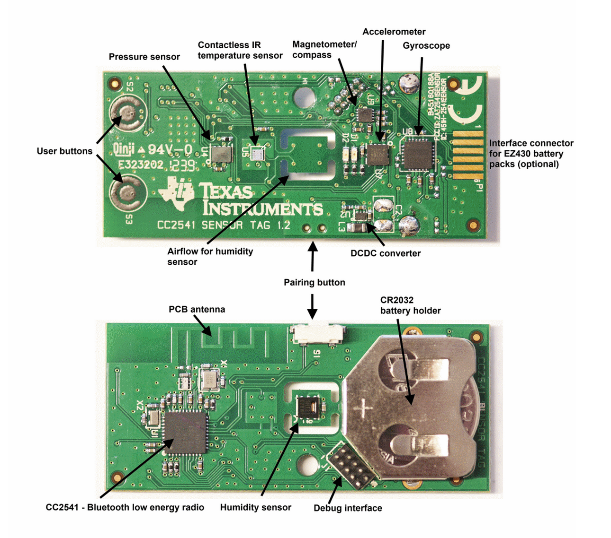

Figure 1: SensorTag Hardware

The Sensor Tag consists of different sensors like IR Temperature Sensor, Accelerometer, Humidity Sensor, Magnetometer, Barometric Pressure Sensor, Gyroscope.

The contactless IR temperature Sensor can measure the object’s temperature in vicinity of sensor with one degree Celsius accuracy. The accelerometer gives the measurement of acceleration in three coordinate axes. It can also measure the gravity’s direction. The humidity sensor gives the temperature and the relative humidity. The magnetometer or compass measures the magnetic field in three coordinate axes. The Barometric Pressure Sensor gives the atmospheric air pressure. The Gyroscope measure the rotation rate in all the three coordinates.

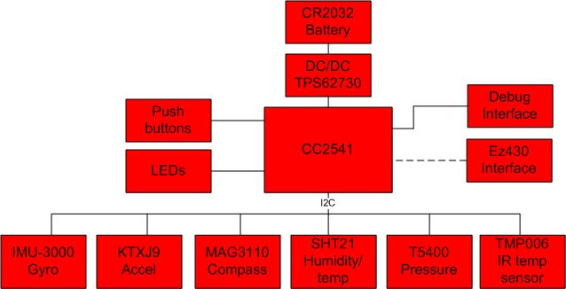

Figure 2: Sensor Tag Block Diagram

Figure 1 shows the physical hardware sensor tag. Figure 2 shows the block diagram.

# HBase

The HBase is a column-oriented database management system that runs on the upper layer of HDFS. It is used to support applications like REST, Avro and Thrift. An HBase system comprises of a set of tables. Each table consists of rows and columns. Each table element is defined by a primary key. and all attempts to access the table must use the primary key. HBase allows attributes to be grouped together as column families, which is different from relational database, where all columns of a row are grouped together. In HBase, the table schema must be predefined and the column families must be specified. It is extremely flexible to add new columns to families to the schema and therefore can easily adapt to changing application requirements. In HBase, the master manages the clusters and the tables are stored in the servers where the work is performed. It is sensitive to the loss of its master node.

# Machine Learning

Machine Learning is a group of statistical analysis algorithms or methods where learning or training is achieved by examples. It is closely associated with domains like Data Mining and Pattern Recognition. Here, we have methods that associate a unknown pattern within a given dataset using likelihood matching. Having options for generalization and inference usually differentiates machine learning. Machine Learning techniques have been successfully used in real world gesture recognitions

# Snake Game

It is top-down 2D game where the objective is to control a snake movement to eat food while avoiding colliding into the boundaries or itself. The movement controls consists of four options, up, down, left and right.

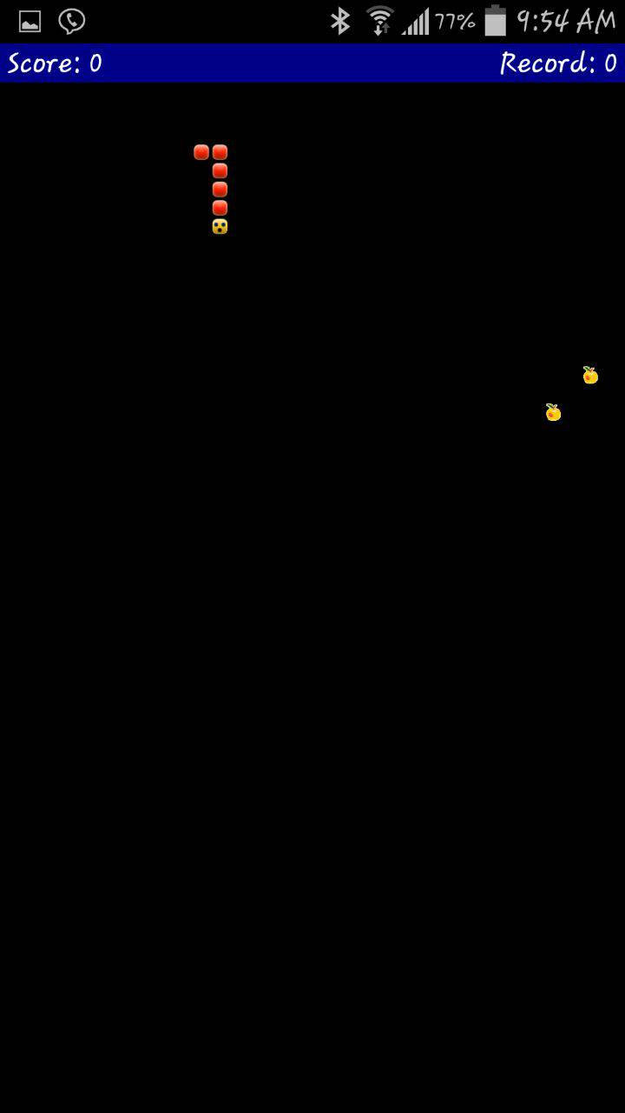

Figure 3: Snake Game

# Implemenation and Results

We have implemented sensor based motion recognition snake game. In actual snake game we have modified the code such that touch event is triggered based on motion recognition. Our project mainly involves i) sensor data collection using sensor tag ii)train the data, iii) Analyzing real time sensor data iv) Invoke respective touch event based on recognized human activity v)Displaying activity results such as number of left to right motions, right to left motions, evaluation results such as accuracy, precision.

In data collection phase, data received from sensor tag is connected to mobile device and data is stored in text files in SD card. We ran track various sensor data parameters like co-ordinates values, accelerometer values. For this project we have collected only x, y, x co-ordinate values. In the training phase, the sensor data collected is trained using HMM model and these text files are converted into respective sequence files.

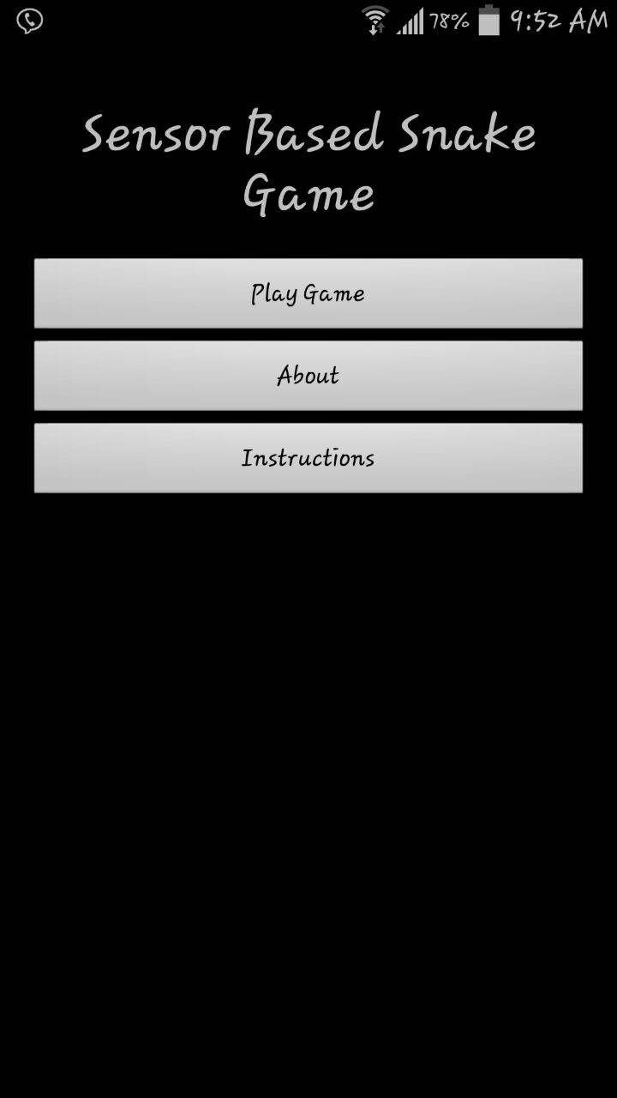

Figure 4: Android App User Interface

When the app is started, train method is invoked in onLeScan method. It collects real time data from sensor tag, converts them into sequence files and compares it with various trained sequence files. It calculates probability between real-time/test sequence file when trained sequence files, sequence file which has highest probability is the selected as respective human motion.

Once the motion is recognized we would broadcast that particular motion then in the game activity file we would receive that motion then based upon the motion detected, function is invoked. For example, if motion detected is say up, then function which make the snake move in up direction is invoked. In this way we are replacing touch event to sensor based event.

We also track the number of activities user has performed say for no of left-right activities, right-left activities etc. We are making use of Hbase to store and retrieve results. In this way we can track results based on each da, month, or year. We also tracking accuracy and precision of our motion detection model. We are making use of pie charts to display results such that user would have a very good visual experience.

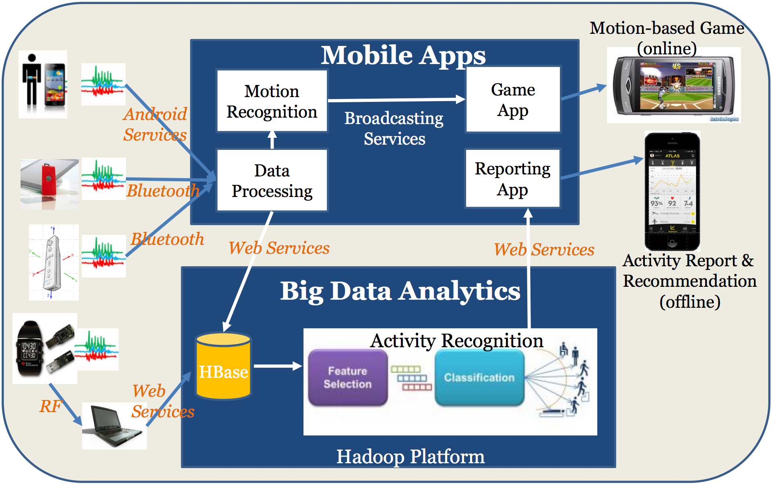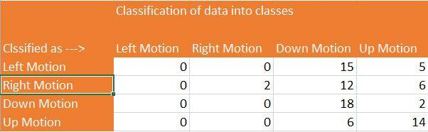

Figure 5: Activity Report Apps using Big Data Analytics Services

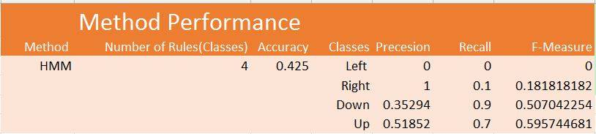

Figure 6 :a) Classification of Data b) Method Performance

# References

[1] F. Bevilacqua, R. Muller, and N. Schnell. MnM: a

Max/MSP mapping toolbox. In Proceedings of the 2005

[2]http://processors.wiki.ti.com/index.php/SensorTag_User_Guide